
Lagos State Employability Support Project - Phase 2
Project Number: 00128856
Output Number: 00122719

2023 Quarterly Progress Report
(April– June 2023)

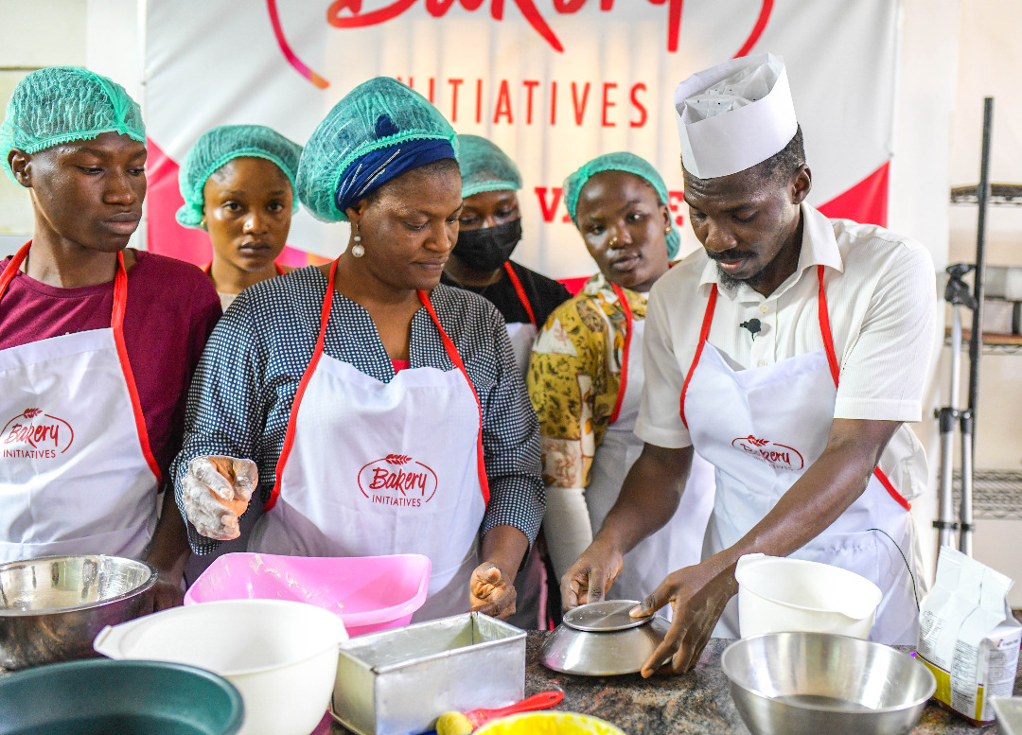
New intakes admitted into Bakery Initiative VTC learning from a previous trainee, Damilola Ayetigbo (now a Supervisor) Lagos, August ,2022. Photo: UNDP

Project Summary | Country: Nigeria  Project Duration: 2 years (2020-2023)  Project Budget: US$2,000,000  Annual Budget: US$3  Cumulative expenditure (US$): $429,256  Contact Persons: Amarakoon Bandara  Team Leader, SPIEG unit  Tel. 09011099008  Email: amarakoon.bandara@undp.org
  Donor | Annual budget US$
  LSETF | US$
  UNDP | US$300,000
Responsible Parties: Lagos State Government/Lagos State Employment Trust Fund (LSETF)

Table of Contents
Acronyms 4
1. Executive Summary 5
2. Progress towards development results 8
2.1 Contribution to longer term results (Max 1 page) 8
2.2 Progress towards project outputs 9
3. Cross cutting issues 12
3.1 Gender results 12
3.2 Gender Results 13
3.3 Partnerships 13
4. Challenges 14
6. Monitoring and Evaluation (Max 1 page) 15
7. Risk management 16
8. Evidence 16
9. Financial Summary 17

Acronyms

AWP  FGD | Annual Work Plan  Focus Group Discussion
ICT | Information and Communications Technology
LASTVEB | Lagos State Technical and Vocational Education Board
LMIS | Labor Market Information System
LSETF | Lagos State Employability Trust Fund
LSESP | Lagos State Employment Support Programme
UNDP | United Nations Development Programmes
VTC | Vocational Training Center
UNDP United Nations Development Programme

Executive Summary

Through the Lagos State Employability Support Project (LSESP), the United Nations Development Program (UNDP) and the Lagos State Employability Trust Fund (LSETF) are addressing the problem of youth unemployment in Lagos State. The project's overall goal is to address the problem of youth unemployment in Lagos state by giving youths between the ages of 18 and 45 years old industry-relevant skills that will allow them to compete in the job market..

The major goal of this project is to increase the State's pool of skilled workers in order to address labor shortages in Lagos State. Another objective is to match skilled manpower with hiring opportunities and ensure no less than 60% of manpower produced either have jobs or are placed on an apprenticeship track to setup businesses in their areas of interest and skill.
LSESP aims to enhance vocational training programs across various sectors, including technology, education, healthcare, construction, art, transportation, logistics, and business support. The project will update the content, improve technical competencies of the labor force, enhance vocational instructor training, and promote the planning and management of training programs. Furthermore, it will address intermediate barriers by ensuring private sector employers' hiring commitments and improving the labor market information system through job matching and promotion activities.

Achievements

- Project delivery Completed 100% for all batches
- Monitoring and Evaluation process to commence in July 2023
- Training, certification, placement, and mentoring for all certified beneficiaries completed, however the M & E report will determine final outputs of placed beneficiaries.
- LSESP enrolled 2,006 beneficiaries and certified 1,868 beneficiaries (93% of the 2,000 target) across 16 different Vocational Training Centers (VTCs) covering 8 different sectors..
- 97% of the certified beneficiaries placed in paid jobs, paid internships, and self-employment.
- Issued start-up tools and gave placement allowance respectively to 175 and 411 certified beneficiaries for Batches 1 and 2 combined.
- Executed an Alumni Forum Event and various Industry Expert’s FGD sessions (physical).
- Onboarded over 600 employers of labor and 692 beneficiaries on the LSESP portal.
- Portal optimization leading to receipt of over 20,000 requests for entry applications.

Challenges

Applicants’ Mobilization: Limitation in enrolling students that have been affected by the ongoing ASUU strike because of the possibility of them dropping out mid-way into the program. Some of them, however, tried to navigate their way into the program by falsifying their educational qualifications at the point of application and screening.
To mitigate this, UNDP Project Manager advised the technical partner to put additional probing questions on the application page e.g, “Are you a youth corps member?”, “Are you a university undergraduate?” “How many weeks can you dedicate towards the training in view of the on-going strike”? This will help to further curb the possibility of applicants cheating their ways into the program due to lack of integrity.

PWD: Challenges have been observed in absorbing PWDs into the project. Considering the special needs that they require and the limitations of the current VTCs to provide same. Only few courses are open for enrollment for PWDS, such as; Sales & Marketing, Customer Service and Baking & Confectioneries.

Program Duration and Target: The number of targeted beneficiaries can be revised upwards to ensure more beneficiaries can partake in the project in future programme designs. The target to train 2000 beneficiaries in two years is conservative.

Lessons Learned
- Improving and extending mentoring sessions for beneficiaries from 3 to 6 months, in view of the feedback received from mentoring partners and beneficiaries stating that the three months mentoring sessions have been less effective and impactful for trainees in the construction sector, especially trainees with only secondary school education. It was agreed that a six-month duration would provide the needed impact, and adequate monitoring will be deployed to address the concerns raised.

- Certified trainees will continue to have access to mentorship and post training support until the end of the project cycle, to allow continuous learning and development.

- High level of interest and participation among the trainees, especially with respect to completing internship opportunities, based on the additional transportation stipends provided.

- Beneficiaries should be monitored more closely during their internship to measure performance, improve discipline and dedication.
- As an alternative to start-up tools, top performing beneficiaries should be sponsored to
take higher level training.

- The duration of training should be increased to allow beneficiaries more time to learn the skills required adequately.
- More emphasis should be laid on corporate etiquette and social skills before beneficiaries are placed for internships.

- Provide orientation classes to improve social skills before beneficiaries are placed for internships.

- Some beneficiaries lack digital literacy skills that are relevant in their industry, this should be provided as a separate course to broaden their scope/understanding on sales and
marketing to increase their earning potential.

Budget

Provisional expenditure up to 30 June 2023, was USD185,678.76 representing a delivery of 61 % of the 2023 annual project budget of USD 300,000

Situation Background

The Lagos State Employment Support Programme (LSESP) was created to tackle unemployment and lack of skilled workers in key sectors. The Lagos State Employment Support Programme (LSESP) was created to tackle unemployment and lack of skilled workers in key sectors.in Lagos State.Project LSESP aims to tackle unemployment by providing youths with employable skills that align with industry needs, closing gaps between training and employment, and supporting changes to the future labor force's profile to make it more competitive and better adapted to the needs of the private sector.

The project trained 2,006 skilled workforces in two years (1,000 per year) to cater to demand in key sectors and has placed 97% of the trained workforce produced in private sector jobs, while 20% have been supported to start their own businesses. Also at least 16 Vocational Training Centers in Lagos have been supported with new vocational curriculum upgrades in partnership with the Ministry of Labor and Employments in Lagos State, while also improving the teaching skills of technical instructors. The project targets unemployed and under employed youths with or without skills and aged 18-45 years with special consideration for women and persons living with disabilities.

This quarter of the project recorded significant progress in the areas of training, job matching and placement opportunities, as well as partnerships with private sector stakeholders. In the focal quarter (April to June), the project completed job placements for Batch 1 and 2, and this remaons ongoing.

Progress towards development results

Contribution to longer term results (Max 1 page)

United Nations Sustainable Development Cooperation Framework (UNSDCF)/Country Programme Document (CPD) Outcome 2: By 2027, Nigeria sustains inclusive economic growth and development that provides equitable opportunities for decent employment and livelihoods.

Summary achievements based on CPD Outcome <add outcome number(s)> targets
CPD outcome target | Summary achievement to date | Status
By 2022, Nigeria has an inclusive and diversified economic growth driven by science, technology, innovation, investment in infrastructure, and job creation. | Through partnership with the Lagos State government, UNDP Nigeria is providing access and skills to increase the pool of skilled manpower in order to alleviate the acute shortages of employable labor in Lagos State, by equipping 1,000 beneficiaries in the first year with relevant skills that cut across sectors, including but not limited to: Technology, Education, Hospitality, Fashion, Construction, Business support, and Beauty. | On-going
Number of new jobs and other livelihoods generated disaggregated by formal and informal sectors and sex | Match skilled manpower with hiring opportunities & ensure that no less than 60% of manpower produced either have jobs or setup businesses in their skills areas. | Achieved
Overall |  | In Progress

Guidance: Please populate the table above. No narrative section is required
Relevant CPD Output <add number> : <Add CPD Output statement>
Summary achievement based on CPD output targets
CPD output targets | Summary achievement to date (provide gender disaggregation) | Status Ongoing, Delayed, Completed
 | Black font, un-bolded | Blue font, un-bolded
 | Black font, un-bolded | Blue font, un-bolded
Overall status |  | Blue font, bolded
Guidance: Please populate the table above. No narrative section is required
Repeat for all CPD Outputs

Progress towards project outputs
Project Output 2: Vocational trainings completed for 2,000 applicants
Summary achievement against 2023 Annual Work Plan (AWP) target
Indicator (as they appear in the AWP) | Indicator Target (2022)  (AWP indicator targets) | Summary achievement during the quarter (provide gender disaggregation) | Status:
Number of Vocational Training Centers with improved curricula | 15 | 16 Vocational Training Centres have received upgraded training and improved curricular in 8 different sectors. | Completed
Upgrade new curricula for 70 instructors | 70 | 78 VTC instructors upgraded and trained | Completed
 | Overall status |  | Completed

Description of Results

Project Output 1: Curricula and training materials for 15 VTCs improved

To further achieve higher levels of employment productivity among trainees, a total of 78 VTC instructors (2021, 43 instructors and 2022, 32 instructors) trained across the selected sectors have been certified as qualified trainers by the Ministry of Labour and Employment. These Instructors have all completed several modules of curricula standardization training, content harmonization and curriculum customization across the eight sectors.

The results from these achievements will ensure that trained instructors are able to equip the trainees with up-to-date skills to meet the increasing demand for skilled manpower to alleviate acute shortages of employable labour across the critical sectors identified during the focus group sessions held with stakeholders across 8 core sectors: (construction, beauty, fashion, information technology, business support and hospitality).

The curriculum harmonization and certificate endorsement for instructors are approved in partnership with the Ministry of Labour and Employment.

LSESP Training Content; developed training course content for 11 technical & soft skills courses across 6 sectors (Information Technology, Fashion, Beauty, Hospitality, Construction and Business support).

Project Output 2. Vocational training completed for 1,000 applicants
Summary achievement against 2021 Annual Work Plan (AWP) target
Indicator (as they appear in the AWP) | Indicator Target (2023)  (AWP indicator targets) | Summary achievement during the quarter (provide gender disaggregation) | Status:
Number of males that complete the vocational training programmes | 300 | 300  males currently in training across 7 sectors and trades | Completed
Number of females that complete the vocational training programmes | 300 | 309  females presently in training across 7 sectors and trades
Number of VTC instructors that benefit from skills upgrade |  | 32  VTC instructors from 16 VTCs have received upgraded skills training across 8 sectors. | Completed
 | Overall status |  | Completed

Description of Results

Project Output 2: Vocational trainings completed for 1,000 applicants
While training duration varied from sector to sector, a total of 2,006 trainees from June 2020 to December 2022 have been successfully enrolled and trained covering 8 different sectors.

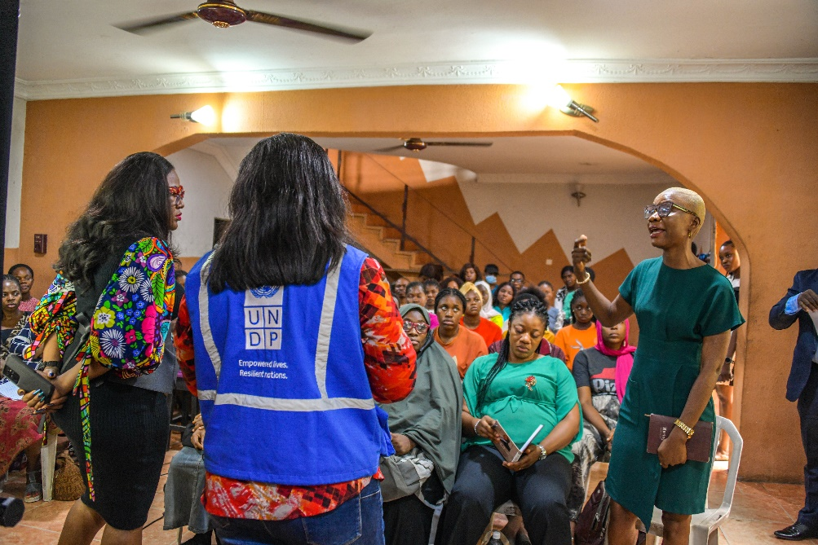
On boarding session with new intakes at a Vocational Training Center in Lagos.
September 2022.

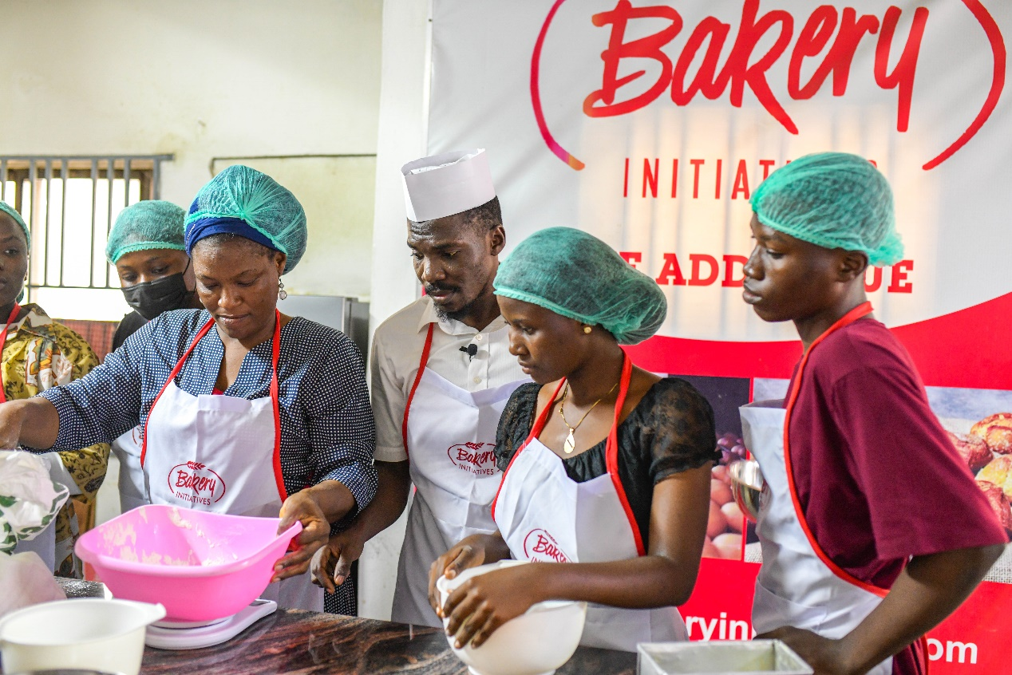
Damilola Ayetigbo a beneficiary from Batch 1, employed as a trainer and supervisor at his VTC, Bakery Initiative, Lagos State

Project Output 3: Improved job matching and skills promotion
Summary achievement against 2023 Annual Work Plan (AWP) target
Indicator (as they appear in the AWP) | Indicator Target (2023)  (AWP indicator targets) | Summary achievement during the quarter (provide gender disaggregation) | Status:
Number of males that gain employment through the job matching and skills promotion or are self-employed | 600 | 694 | Completed
Number of females that gain employment through the job matching and skills promotion or are self employed | 600 | 1,133 | Completed
Number of participating private sector companies | 150 | 400 | Completed
 | Overall status |  | Achieved

Number of males and females that gain employment through job matching and skills promotion or are self-employed

Among the certified trainees, the project has placed 1,828 of them in jobs (97%) ranging from contract, full time jobs, paid internships and self-employment. Women make up 62% of placed beneficiaries and men 38%.

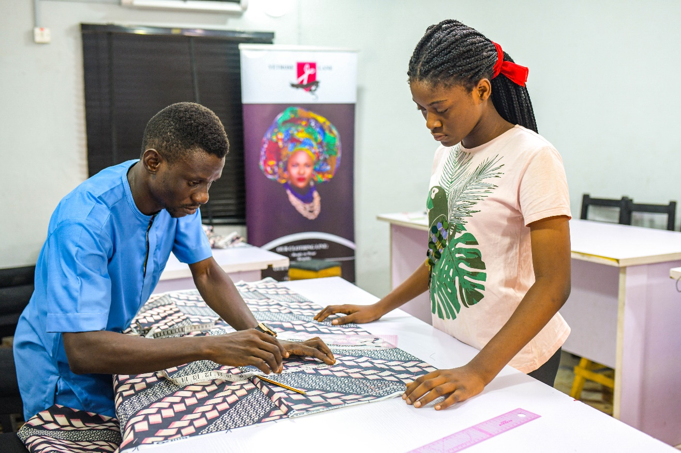
Daniels Oluwatobiloba a supervisor at Yetroslane Fashion Academy and former trainee (Batch 1) provides pattern drafting sessions to a new intake in Batch 4

In addition, the project has directly and indirectly partnered with various stakeholders, such as vendors who provided additional services towards the actualization of the programme, , VTCs who employed more resources and manpower, and provided direct employment through:

  - Onboarded and upskilled 16 vocational training partners with new soft & technical skills vocational training curricula.
  - Renovation and upskilling one public sector training center.
  - Trained 78 technical instructors (male & female) to s
  - Executed training with 16 active training partners, setting up centers across 23 locations situated in 21 LGA’s within Lagos State

Cross cutting issues

Gender results
Gender results | Evidence
Gender result 1: Ensure 50% participation of women  Presently, out of the total selection of trainees enrolled 62% are females and 38% are males. | Evidence 1:  - Project report from Implementing Partner.  -Training report from IP
Gender results 2: 69% of males admitted into traditional male-dominated vocational education sectors (construction. ICT, Business support). Females 31%.  90% of females admitted into more traditional female dominated vocational skills (Fashion, beauty and hospitality). Males- 10% | Evidence 2:  - Project report from Implementing Partner.  -Training report from IP

Gender Results

To mainstream gender at project design level, gender equality (marked 2), ensures a minimum of 50% participation of women, incorporated as one of the main objectives of the project and is fundamental in its design and expected results. Also, selected courses such as Hospitality, Fashion and Beauty industry are sectors with high opportunities for job placements for women.

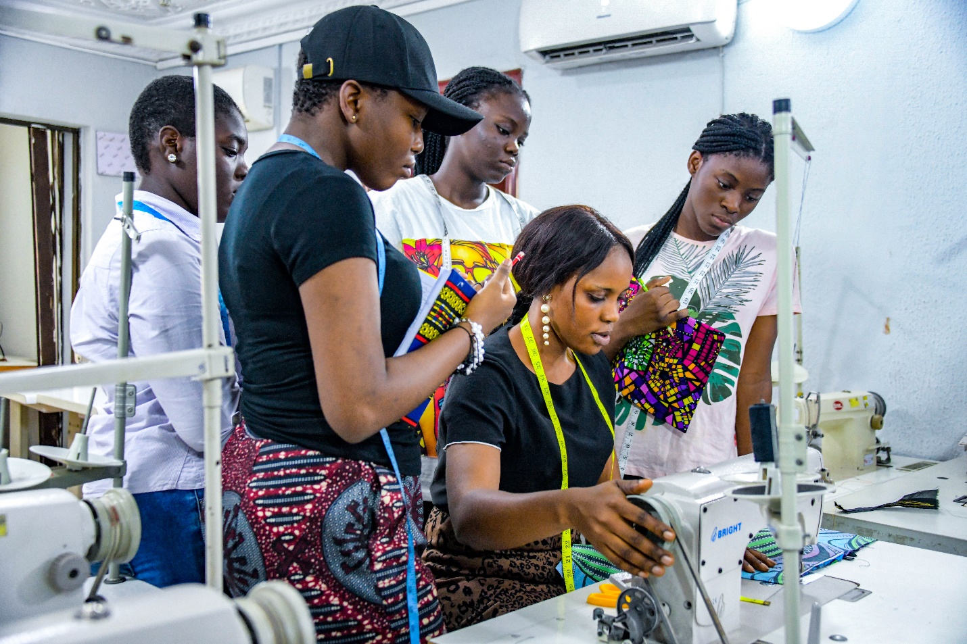
Beneficiaries admitted into Batch 4, observing a supervisor during a session.

Partnerships

UNDP’s partnership with the Lagos State Government, through the Lagos State Employability Trust Fund is providing relevant intervention in tackling the very high levels of unemployment in the State and preferring lasting solutions to the Sustainable Development Goal 8: Promote sustained, inclusive, and sustainable economic growth, full and productive employment and decent work for all and Goal 1: End poverty in all its forms everywhere. Similarly, through the LSESP project, partnership with the Ministry of Labor and Employment.

The project has also partnered with 400 private sector businesses ranging from MSMEs, and large corporations.

Environmental Considerations (max 1/2 page)
If applicable, describe how environmental considerations are taken into account:
  - Does the planning and implementation of the project take environmental considerations into account, and if so, how?
  - How does the project contribute to the sustainability of the environment?

South to South and Triangular Cooperation (max 1/2 page)
Guidance: List the types of South to South and Triangular Cooperation that the project was involved in during the year. Which countries (1st column) and type of cooperation (2nd column)
Country | Type of cooperation

Strengthening national capacity (max 1/2 page)
Guidance: Describe national capacity strengthening initiatives and results for the quarter
Results achieved | Institution | National capacity strengthened

Monitoring and Evaluation (Max 1 page)
Key M&E activities conducted during the quarter [ensure alignment to section 3 - how progress was evaluated]

Key M&E activity (monitoring visit, evaluation, review exercise) | Key outcomes/ observation | Recommendation | Action taken
M&E activity 2: Project Board/Steering committee meeting | VTCs Expansion: To find the possibility of expanding our VTC reach to the remote areas.  PWDS: strengthen the inclusion of PWDs to ensure no one is left behind  Continue with the LSETF and UNDP Programme for phase 3: Send an official letter to communicate interest in Phase 3 to UNDP to allow for more employment opportunities with additional support for entrepreneurship track | Partner with more VTCs and support VTCs to expand using either loan facilities at very reduced rates through the Lagos State loan programme, as well as other viable means to integrated payment into project deliverables  Develop PWD specific curriculum and engage VTCs dedicated solely training PWDs trainings.  To be reviewed by UNDP, after recommendations from stakeholders | To be considered for phase 3  To be considered for phase 3  On-going

Risk management
Risks | Mitigation Measures
Fewer admission and enrollment into training rooms due to restrictions and precautions caused by COVID-19. | Initiation and adoption of blended learning to support training needs.
The use of biometric device to capture trainee’s attendance may breach covid-19 safety protocols | Adopt a dedicated sign in register to support attendance and gradually phase pit the use of biometric devices, while ensuring strict compliance to hand washing and use of alcohol-based hand sanitizer,

Challenges

- Challenges experienced in mobilizing applicants for the construction courses (masonry) particularly in the Ikorodu axis. However, other sectors continue to attract more interested and qualified trainees.

- Many construction applicants were unable to apply for training via the online application portal, highlighting the need for earlier digital skills training in the project..

- 7. Lessons Learned

- Social contracts on the project should be adopted to ensure beneficiaries are socially responsible towards the project’s growth and sustainability.

- Review the M & E component and the Theory of Change to meet changing needs in the system.

- Ensure that the soft skills component is enriched and further developed to build confidence and communication skills of trainees. This includes on-going review of the soft skills curriculum.

Evidence

- List evidence of achievements of the project towards the outputs during the reporting period

Report Section | Title | URL link
Output 2 | Graduation | https://studygreen.info/lsetf-undp-vocational-training-program-2022/
Output 2 | Graduation (video) | https://www.youtube.com/watch?v=30vnsiYgDVs
Output 2 | Students’ application portal | https://www.lsesp.ng/content/apply-undp-application
Output 3 | Public announcement for employer visibility | https://www.ng.undp.org/content/nigeria/en/home/projects/Lagos-state-employability-support.html

Financial Summary
Outputs / Activity Result |  | Current Annual Budget (US$)  (Jan – Dec 2023) | Expenditure (Reporting Period)  Jan-June 2023 | Cumulative Expenditures  (delete column for Q1) | % Expenditure  (Cumulative)
 |  | A | B | D | D/A*100
Output 1: Curricula and training materials for 15 VTCs improved
Activity Result 1.1 | Improved curricula for 15 Vocational Training Centers
Output 1 Sub-total
Output 2: Vocational trainings completed for 1,000 applicants
Activity Result 2.1 | Vocational trainings completed in selected trade areas
Output 2 Sub-total
Output 3: Job matching, and skills promotion improved
Activity Result 3.1 | Job matching and skills promotion improved.
 |  | 300,000 | 185,678.76 |  | 61%

